Market Data & Scenario Analysis

Business Description

Hexcel manufactures and sells advanced materials made of carbon fibers to Commercial Aerospace (69%), Space and Defense (17%), and Industrials (14%) end markets.

Investment Theses

* Highly defensible moat that yields superior ROIC to peers due to 1) vertical integrated business model that creates 2) positive feedback loop that provides incremental synergies to future acquisitions, which helps with 3) product innovation that makes customers’ switching cost even higher
* Leading industry position that will benefit from increasing secular demands for advanced composites as newer airplane models will have higher composites makeups for fuel efficiencies, strength, and durability
* Prudent capital structure and attractive margin profile gives the company more breathing room in times of crisis as 1) the earliest debt maturity is in 2024, and 2) a favorable cost structure for the Composite Materials segment, where most of sales comes from
* The Street thinks the company is fair valued with most pessimism priced in and a short-term focus, therefore discredit the premium multiple the company used to trade at. The sell-side also believe that HXL’s recovery is slower than peers due to exposures to greater wide-body exposure. However, I think the company still deserves a premium valuation and the recovery should be faster than expected

Considerations

* Customer concentration: Airbus (39%) and Boeing (25%) together make up most of the company’s sales, which means Hexcel’s topline performance is at mercy of these customers’ build rates and contractual status. However, it is worth noting that the commercial aerospace is a duopolistic industry, the company’s exposure to these two companies is fairly reasonable. Further, contracts with these two players are usually long-term, so there is a very low likelihood for the company to lose these two customers. The drivers behind the airplane productions are cyclical, but the recessionary analysis shows a manageable decline in revenues from the commercial aerospace segment and the recovery was fast.
* Prolonged COVID-19 impact: the virus has more negative impact than an economic downturn to the aerospace industry as restrictions on air travel and the fear discourage the flight traffic. However, this would be a one-time problem as infected cases will saturate, and vaccines will likely roll out in 2021. More, revenues from Space and Defense segment would be less affected due to a stable budget spending.

Historical Financials & Projections



*Source: Company filings.*

Company Overview

Hexcel was founded in California as an advanced materials manufacturer. Founders were engineers from UC Berkeley. The company leverages its first-mover advantage to secure deep and long-term relationships with players in the aerospace industry. Recently, the company focuses on providing and innovating advanced composites through internal R&T as well as roll-up acquisitions.

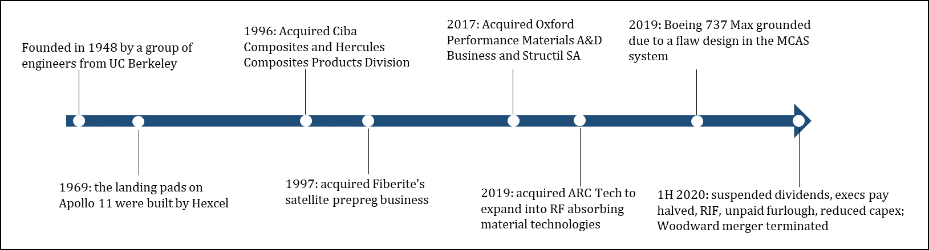

Revenue Breakdown

The company has two reportable segments:

* Composite Materials (~80% of FY2019 sales, 21% operating margin): Hexcel produces carbon fiber, resin, prepregs, honeycomb and other composite materials that are used to reinforce structures and/or to produce more complex products.
* 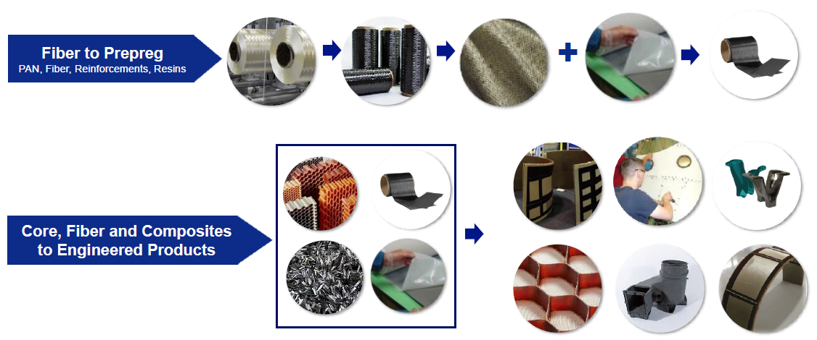Engineered Products (~20% sales, 14.6% operating margin): using advanced machining techniques, the company makes Composite Structures like helicopter blades, Engineered Honeycomb, and RF Interference Control products (through ARC Technology acquisition).

*Source: 2019 Investor Presentation by Hexcel*

However, it is more important to look at end markets the company is selling to.

* Commercial Aerospace (68% sales): in this segment, Airbus takes 36% and Boeing takes 23% of sales. The rest goes to regional and business aircraft makers.
* Space and Defense (19%): F-35 joint strike fighter (JSF) is the largest program, which accounts for less than 25% of sales within this segment. The company supplies materials to helicopters, V-22, and other military programs.
* Industrials (13%): Vestas is a primary customer in this segment as a wind-energy company. Hexcel also serves transportation, marine, automotive and other applications within this segment.

Thesis I: Highly defensible moats

Vertical Integration: in order to establish reliable relationships with customers, companies like Hexcel must ensure that they have a better control of carbon fiber and its feedstock supplies. More, due to proprietary manufacturing process and very tight manufacturing tolerances for aerospace applications, vertical integration helps Hexcel stay competitive by offering high quality products on a timely manner.

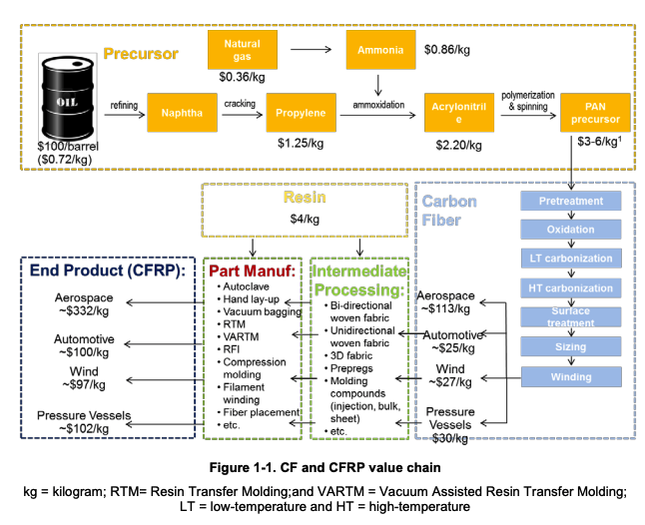

Hexcel has manufacturing capacities for everything in this zone, **all assets are** **aerospace qualified**. The company consumes 75% of carbon fiber produced and sells the rest to third parties including competitors. Sometimes the company purchases CF from other firms due to special qualifications demanded by the customers.

Hexcel has invested in many facilities to expand its CF capacities. As of 2019, **Hexcel has the largest aerospace qualified CF capacity and broadest product portfolio.**

*Source: Global Carbon Fiber Composite Supply Chain Competitiveness Analysis*

It is impressive that a pure-play firm would have so many (24) manufacturing facilities to help increase margins and strengthen the relationship with customers, who are increasingly adopting just-in-time inventory management method. To ensure that, the company also have strong compliance and requirements for its suppliers. Hexcel **demands its suppliers to deliver raw materials in three days max**. This indicates the strong bargaining power Hexcel has over its upstream value chain. Having a control of the quality and quantity of Hexcel’s CF supply enables the company to make subsequent acquisitions more synergetic.

Synergetic Acquisitions: the company’s earlier acquisitions of the upstream supply chain give it the ability to manufacture high quality carbon fibers with unique surface characteristics. And that allows the company to make more synergetic acquisitions. For example, the merger with Oxford Performance Materials has been synergetic as the Hexcel carbon fiber is preferable for addictive thermoplastic applications due the said surface features. **The investment is paying off as Boeing just added Hexcel on its Qualified Provider List for its HexPEKK end-use components as well as the addictive manufacturing processing using laser sintering.**

Most recently, the company acquired ARC Technologies in 2019 to strengthen its presence in RF absorption materials offering. That would help Hexcel capture more market shares in the Space and Defense sectors. **The $160 million buyout generated $50 million annual revenue, adding 2% growth to total sales growth of 8%.**

**Each prudent acquisition reinforces the moat and creates a positive feedback loop**. With more diversified technologies, the company can sell them through the existing customer channels, which would increase customers' switching cost because they suddenly have more product offerings from their trusted vendor.

Which means… Hexcel’s quality assets and strong customer relationships are not only represented by multi-year long contracts, but also by superior ROIC and ROE to its peers.



*The dip in 2017 metrics reflects a reduction in sales of legacy wide-body airplanes.*

Furthermore, ROIC is an important metric for executives’ performance-based compensations. This allows the management to make prudent acquisition decisions and effectively use the capital. The compensation structure also aligns the management’s interests with shareholders, as shown by the impressive 20%+ ROE, when the peer’s best number is only 14.8%, scored by Teijin in 2016.

Hexcel’s Commercial Aerospace sales to Airbus and Boeing and their subcontractors accounted for 59% of total 2019 sales, and their airplane backlog is over ten years based on 2019 deliveries, which were unusually low as a result of the grounding of the Boeing 737 MAX.

Thesis II: Industry tailwind and the leading position

Since the invention of CF composites, there has been an exponential demand for incorporating such material into airplanes’ primary and secondary structures due to the fuel efficiency CF composites generate. Both Boeing and Airbus, along with military programs, have introduced composites into their models.

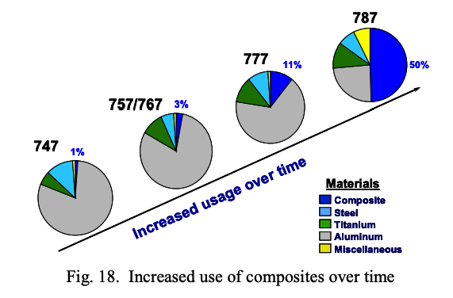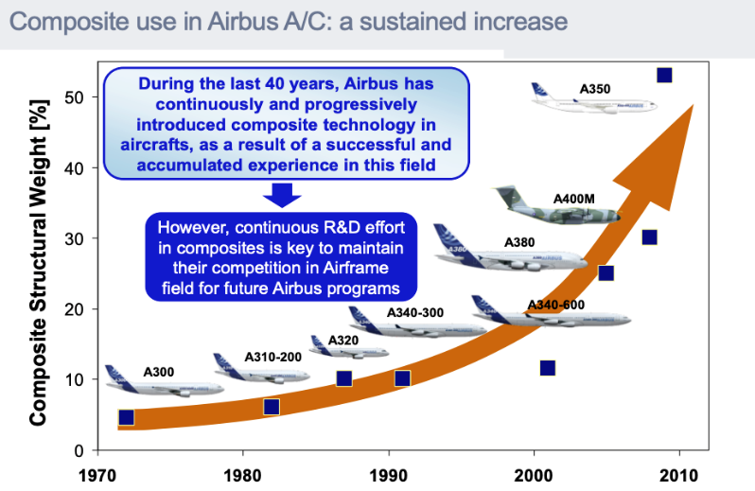

In addition, existing legacy planes will be inevitably replaced by newer planes due to higher costs associated with operating those older planes. Therefore, the Aerospace Composites has become a very attractive industry.

However, the Aerospace Composites is **a highly consolidated industry with only a few major players**: Teijin, Toray, Solvay, Hexcel, and Gurit. We will exclude Gurit from our analysis because its size is simply insignificant. Solvay’s $5.5 billion merger with Cytec in late 2015 and Toray’s $583 million acquisition of Zoltek in 2013 had made Hexcel **the only public pure-play within this industry**. More, the Woodward merger indicates that this industry is still consolidating, and pure-play firms like Hexcel would make attractive buyout targets.

Despite rivals’ roll-up acquisitions and synergies created through those mergers, Hexcel has been remaining its leadership position in the industry, showing the strength of the company’s moat.

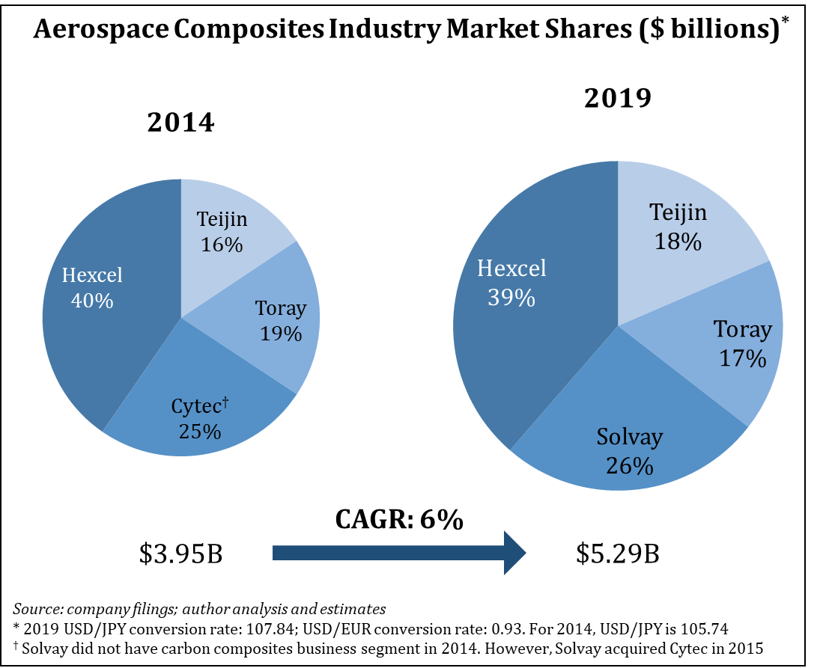

I expect the industry **growth would exceed a 6% CAGR** in the long term as the number of middle-class households increase as a result of the economic growth from emerging countries. The COVID-19 interruption would delay airplane productions and discourage people from traveling; however, the increase in composites demand is inevitable. The same can be said for other industries like wind energy, automotive, medical devices, etc.

Within the aerospace industry, Hexcel generates more sales from Airbus than Boeing. The opposite is true for Toray. I believe the strong relationship with Airbus would be another tailwind because Airbus has more composite-heavy models than Boeing. And **A350 units generate the highest content value ($4.8 million) over other models**. Revenues from A350 program alone are more than all Boeing programs combined after the 737 Max grounding. Less than 10% of revenue comes from 737 Max program, which is a good mitigant to the topline performance of the company.

*Source: Company filings; Goldman Sachs Global Investment Research*

Thesis III: Prudent capital structure and attractive margin profile

In 1Q 2020, the company drew an additional $380 million from its RCF, which left an amount of $693 million outstanding out of the $1b available amount. The prudent capital structure allows the company to borrow more cash from its revolver to provide short-term liquidity without triggering any financial covenants. More, **the earliest maturity wall for Hexcel’s debts is in 2024**, which is far enough to avoid any credit crunch within our investment horizon. Because of the high FCF generation, I believe the revolver burden **would** **be paid down by $400 million in the next two years**. This prudent capital structure allows the company to weather short-term adversity without being forced into a bankruptcy.



*Source: Company filings; FINRA*

It is worth noting that the company has a favorable cost structure for its Composite Materials segment, where 80% of sales comes from. That CM margin did not drop as much from the average. However, due to a high fixed cost mix, the Engineered Products suffered a significant decremental margin in 1Q as sales of this segment down 16% YoY.

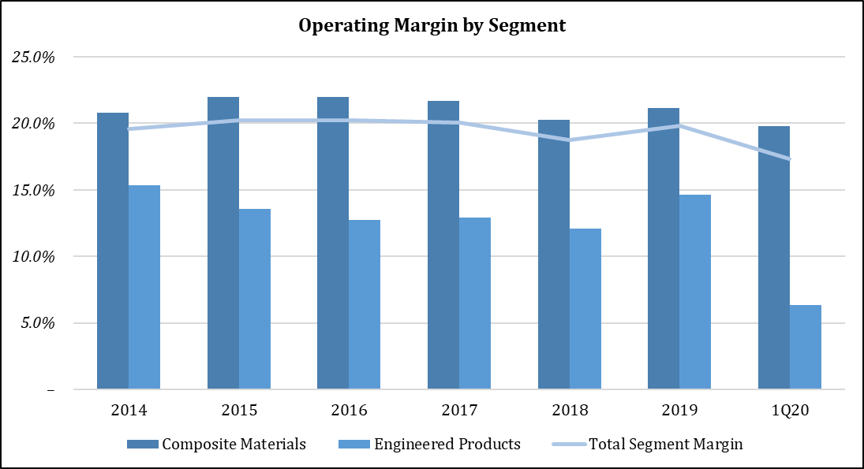

*Source: Company filings*

It would be interesting to see how Hexcel had sailed through previous recessions including 9/11.

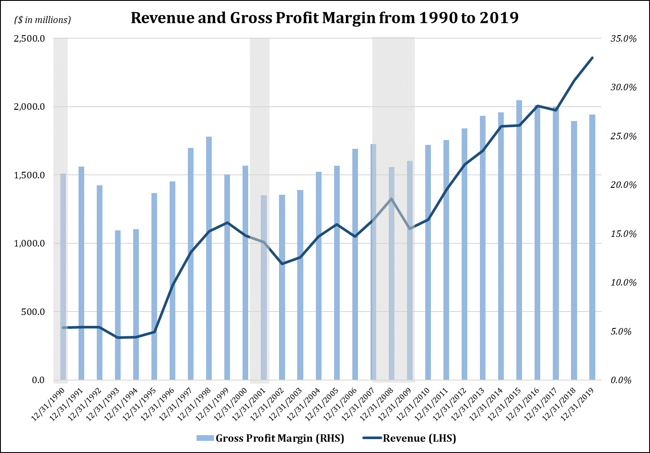

*Source: Company filings*

While the revenue has been affected the most due to the overexposure in commercial aerospace, the company was able to maintain good levels of gross profit margins through difficult times.

If we look closely at the CM segment, Airbus and Boeing only declined by a moderate amount and quickly recovered the revenue growth. That indicates the **reliability of the contracts and the sticky relationship with these two giant**s. The impact from Boeing was less than Airbus because Hexcel’s sales is more weighted towards Airbus, who awards high content value. However, this time we should see a different story due to the 737 Max issue. I expect sales from Boeing takes a sizable dent as 737 recert delays indefinitely due to the virus.

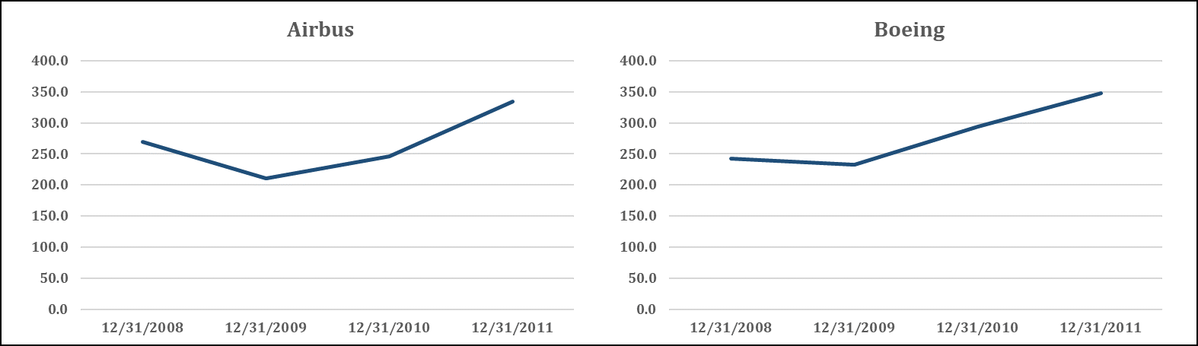

*Source: Company filings*

Looking at other end markets within the CM segment, it appears that the Space & Defense is the least affected sector as the national budgets for military programs did not get curtailed as much. **However, sales from Industrial was most vulnerable as contracts are usually short-term and on-demand based**.

*Source: Company filings*

**Things from the EP segments were pretty interesting**. Sales from Boeing in this segment actually soared during the GFC.

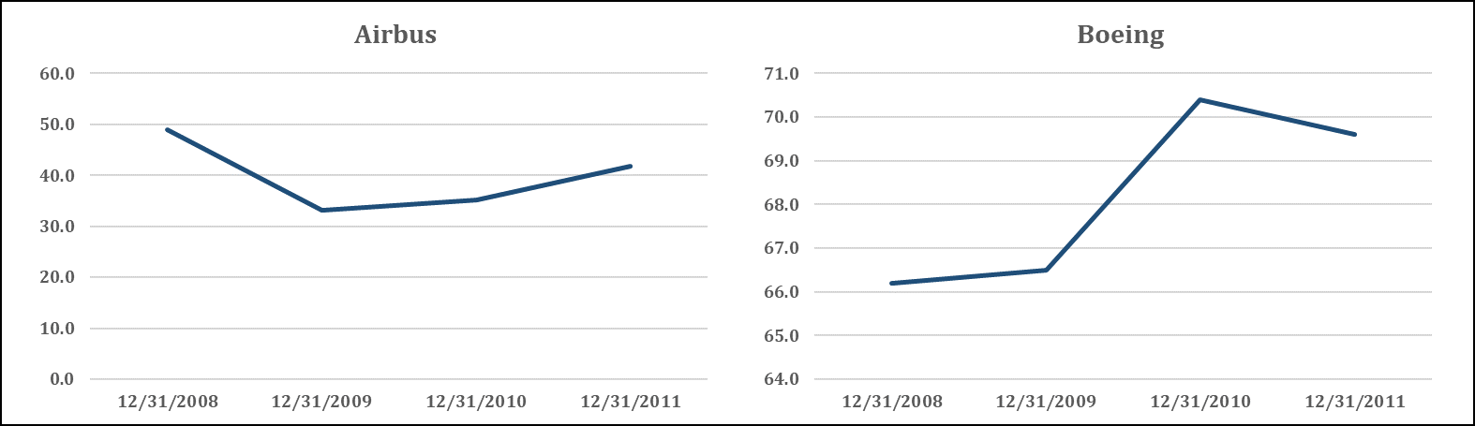

*Source: Company filings*

Perhaps it was more costly for Airbus to assembly its planes due to its more fragmented supply chain nodes that are dispersed across the globe.

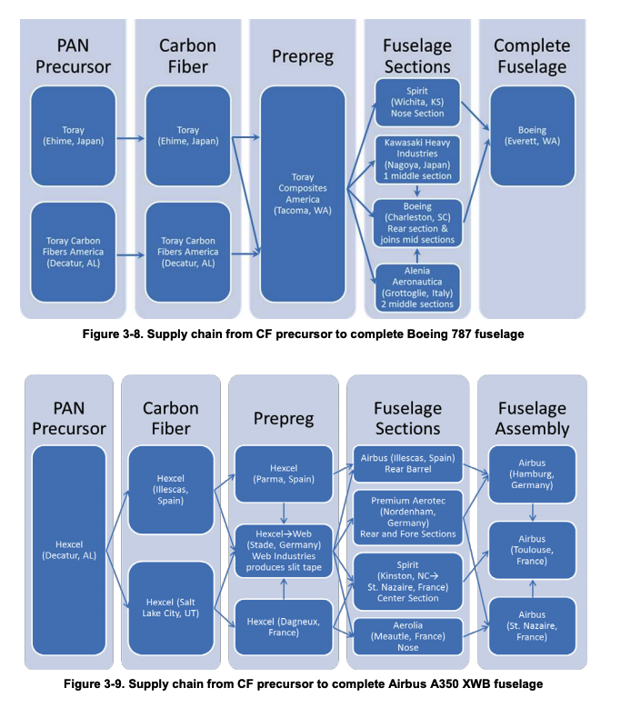

*Source: Global Carbon Fiber Composite Supply Chain Competitiveness Analysis*

This might explain depressed margins from the EP segment we see in 1Q 2020. The virus has resulted in global fight restrictions, it would be very difficult for Hexcel to airship raw materials to its foreign manufacturing sites.

As the management shuts down the Roussillon facility in France, the company is left only one precursor (a raw input for CF) in the US. It indicates the fungible nature of those feedstock materials as the management has to store the excess ones in a fridge for repurposing, which would be an unnecessary fixed cost given the overall plane build rates have declined. This would be an effective way to mitigate the margin depression.

Throughout the GFC, the revenue from the EP segment was pretty stable. The only erratic sector is Industrial. The margins did not depress much during the recession, **which contradicts to what happened in 1Q 2020**. I think the reduced build rates combined with the 737 Max grounding have more impact than a “normal” economic recession. But the bright side is that COVID-19 and the grounding are short-term issues and they would eventually go away in at most 2 years.



*Source: Company filings*

Thesis IV: What does the Street say?

Most sell-side analysts have assigned a neutral-rating to Hexcel for a few reasons:

* They think Hexcel no longer deserves to trade at the historical 20% premium over peers, because the growth is restricted due to current events.
* They are valuing the company using a two-year horizon, which is IMO short-sighted for my investment objective.

As shown in the recession analysis, Hexcel was able to maintain reasonable margins in the boiling water. I think this alone indicates the quality of the business**, especially given that Hexcel is a pure-play that has much more exposure to the economic cycle than its peers,** whose composites segments only account for less than 30% of EBITDA.

Furthermore, as mentioned earlier, the company’s return on capital is the best among comparable peers. I think the sell-side only sees the company as a growth story, **they have overlooked the underlying assets that generate more economic values than what the topline growth rate says**.

In addition, from a simple valuation perspective, the company is trading well below its peers. I don’t think this subpar P/E multiple fairly values the company, who also has the highest earnings margin among peers.



I think the company makes an attractive value investment opportunity at current price level, where most of pessimism about the virus and the aerospace industry have priced in. It takes patience for the company’s stock price to get back to the pre-COVID-19 level, **but it would be unreasonable to rate companies affected by the virus the most on a short-term basis**. This is like to assess a company’s performance using a reported EBITDA that has been affected by some huge one-time charges.

Valuations

I try to keep it as simple as possible. I’m only projecting out the revenue and EBITDA. And for my base case scenario, I use assumptions that are **even more conservative than the neutral-rating sell-side assumptions**.



My upside case for EBITDA margins from 2020 to 2023 comes from Goldman Sachs’s base case projection. For my conservative base case, I simply assumed a slower margin recovery.

My downside cases are very pessimistic, I’m basically assuming that the company is losing most aerospace sales in 2020, which is highly unlikely because new planes are still being built, albeit a slower pace. For margins, I assume this virus has done a long-term damage on the company so that it will not return to the 20% level until 2024.

Here’s the output:



I assumed a 12x EV/EBITDA for my base case because that has been the historical average for industry. For the sell-side case, I used a 11x multiple to indicate the general pessimism.



For shares outstanding, I assumed a 3% shares buyback each year.

**Even with the extreme bear case and a very conservative base case, the risk/reward is still very attractive**.

Catalysts

* Travel restriction liftings
* Countries reopening their economies
* 737 Max recertification
* Build rates restore to the normal level
* Upcoming earnings release

Appendix







